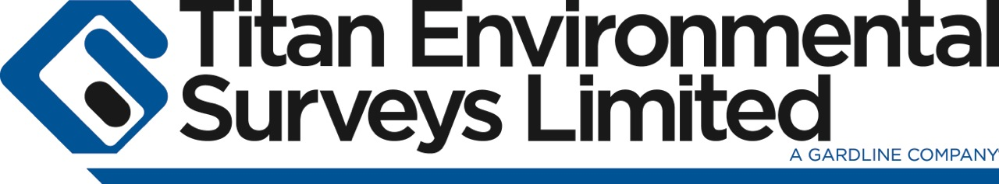

**Titan Environmental Surveys, as part of The Gardline Group, are a market leading marine survey contractor, specialising in nearshore Hydrographic, Geophysical, UXO, Environmental and Met Ocean surveys.**

Project Surveyor – Nearshore

Are you a bright and ambitious individual with a passion for survey, an eye for detail and an ability to coordinate cross functional teams?

For the right candidate, an exciting opportunity has arisen to join the team at Titan, a market leading specialist with a 20-year history in nearshore survey. As a Project Surveyor, you will play a pivotal role in helping us expand our nearshore survey team as we continue on our path as the survey contractor of choice.

**Who are you?**

The ideal candidate will:

* Have significant practical experience in executing marine surveys in one or more of the following fields, Geophysical, Hydrographic, UXO, Environmental or Met Ocean
* Be proficient in managing projects at an operational level within these environments.
* feed into the company’s strong team ethic, with a can-do attitude, while able to build strong working relationships between multi-disciplined functions and varied client base.
* Have a focused and pragmatic approach, relishing the pressure of deadlines and willing to take ownership and make decisions.
* You will be curious, and willing to challenge the status quo, with the ability to identify and implementing solutions.

**What will you do?**

* Review, understand and communicate the requirements of assigned project, defining clear objectives to meet expectations.
* Plan and coordinate the appropriate use of internal and external resources, to design and execute the project plan in accordance with project specifications.
* Support the field team with equipment mobilisation, and provide technical support as required throughout the project.
* Fulfil project reporting, administrative and logistical aspects of survey management in co-operation with the Operations Management team.
* Coordinate project wash-up meetings, and delegate improvement plans as required.
* Contractor management of 3rd party services and provide seamless integration into Titan’s operations.
* Support technical and commercial functions in the development of our survey capability.
* Adhere to, promote, and advance company QA and HSE processes, practices and systems.

For someone with the right combination of skills and knowledge, the role is both challenging and rewarding in equal measure. Titan offer a competitive salary and benefits package.

Please note, this role is an office-based role, based in Bridgend, South Wales with an expectation of 60 days away from base per year.

**If you believe you have the experience, skills and ambition for this challenging role, please e-mail your CV and covering letter to** [**applicants@titansurveys.com**](mailto:applicants@titansurveys.com)

**Closing Date: 13th April 2021**